Creating and editing resource bundle pop up boxes

Please note that it is essential to test out any edits before overwriting files. I recommend you keep a master copy of all the correct files, and then make a copy of this for editing purposes, only replacing files in the master copy when you are absolutely sure all edits have worked correctly. I also recommend you keep a master copy of all the files as originally delivered by us, so that there is an original to refer back to should something be accidentally altered or erased.

The "maps in time" interactive is comprised of several different flash files.

There are 3 levels of flash file in the interactive.

level 1: "maps-in-time" fla
level 2: "zoom" fla's
level 3: resource bundle pop up box fla's

The top level file is "maps-in-time.fla", and the other files are loaded into this file as needed. Next there are 11 flash files containing the zoomed in maps (eg zoom-1914.fla contains the first map), and finally a set of flash files containing the information for each individual resource bundle pop up window.

Resource bundle pop up boxes are relatively easy to create and edit.

Editing a pop up file that already exists

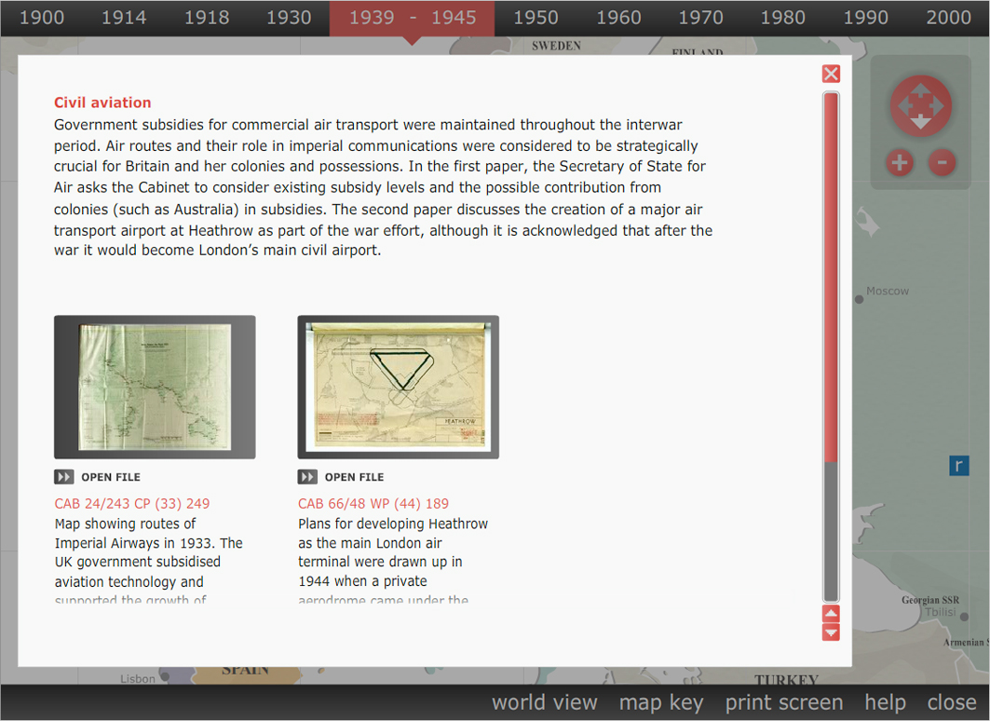

Please note that these pop up files only hold the content of each pop up. The white background box, scrollbar etc are added automatically as needed by the maps-in-time flash file.

Example:

Say for example you want to edit the "Civil aviation" pop up box, you will first have to open the file "43-aviation.fla" located in the "resource-details" folder.

Once you have opened it, you will see that the timeline has 2 layers. The top layer is a mask layer. The other layer contains all the visible elements in a clip called "content".

Go to the library, and double/right click the "content" clip so that it appears on the stage.

You will see it contains 2 kinds of element.

Firstly there is the intro text, running along the width of the stage with a bold red heading and text underneath. This is simply static text and can be edited however you wish.

Beneath this there are the elements that contain info about each resource that can be viewed. These run in three columns across the screen. Each one is a group of items stored in the library as a button. This is so they can be made clickable in their entirety.

While in the "content" mc, click any of the button elements (eg CAB 24/58 GT (18) 5190) and you will see the script that launches the associated resource:

on (release) {
getURL("resource-downloads/cab24-58-gt18-5190-a.jpg", "_blank");
}

You will also see that this particular button is an instance of "B1" in the library. Double/right click B1 in the library to make it editable on the stage.

You will see from the timeline that it is set up as a button, with up and over states. Only the "Open file in a new window" text and icon alter between these states. They are in their own layer. All the other elements, the ones you might want to edit, are in another layer, which runs the length of the timeline from "up" to "hit".

The text here is just static text and can be edited as you wish.

The thumbnail images are imported to the library then positioned on the stage. If adding new images, ensure they are centred over the dark background framing box and have a minimum 5px margin.

To create a new button link, simply duplicate a button from the library, rename it, edit it as needed, then position it in the "content" mc and give it the correct url in the actions palette.

Creating a new pop up file

It is quite easy to create a brand new popup file. Just open one that already exists (eg "43-aviation.fla"), and resave it with a new (and appropriate) filename. Then edit the content within your new file as described above.

Please read the other files for help on how to link the new pop up box into the activity as a whole.

